|  |  |  |  |  |  |
| --- | --- | --- | --- | --- | --- |
| **NO** | **COMPONENTS** | **QUANTITY**  **(PCS)** | **ESTIMATED PRICE** | **REAL PRICE** | **INQUIRY** |
| 1 | Arduino UNO | 01 | 850 birr |  |  |
| 2 | 16x2 LCD Display (with header) | 01 | 200 birr |  |  |
| 3 | Soil Moisture Sensor | 01 | 150 birr |  |  |
| 4 | Water Level Sensor | 01 | 150 birr |  |  |
| 5 | 5V Relay Module 2 -Channel | 01 | 250 birr |  |  |
| 6 | 12V DC Brushless Water Pump Submersible | 01 | 500 birr |  |  |
| 7 | 12V Electric Solenoid Valve | 01 | 500 birr |  |  |
| 8 | Transparent Plastic Tube Hose | 2 Meter | 40 birr |  |  |
| 9 | Piezo Buzzer | 01 | 100 birr |  |  |
| 10 | LED Green(1), Yellow(1) Red(1), | 03 | 3*3 birr |  |  |
| 10 | POT/Variable Resistor (10k) | 01 | 30 birr |  |  |
| 12 | PVC foam board plastic flat sheet | 04 | 4*200 birr |  |  |
| 13 | Glue Gun sticks | 02 | 2*20 birr |  |  |
| 14 | LM 2577 DC to DC Auto boost buck Convertor 1.25v-30v | 01 | 350 birr |  |  |
| 15 | Stepdown Transformer /12v output | 01 | 150 birr |  |  |
| 16 | Bridge Rectifier | 01 | 35birr |  |  |
| 17 | Electrolytic Capacitors 2200uf/25v, 1000uf/25V, 470uf/16V | 03 | 3*5 birr |  |  |
| 18 | Resistor 100 ohm | 03 | 4*3 birr |  |  |
| 19 | Regulator LM7812 & LM7805 | 02 | 2*10 birr |  |  |
| 20 | 65 Jumper Wire. (22M-M,21F-F, 22F-M) | 1 Pack | 160 birr |  |  |
| 21 | PCB Strip Board (Dot type) | 01 | 80 birr |  |  |
| 22 | SPST with Red Light Indicator On OFF Boat Rocker Switch | 01 | 15 birr |  |  |
| 23 | 2 Pin Terminal Connector | 02 | 15 birr |  |  |
| 24 | 2 Litter Water Bottle or Highland | 02 | 30 birr |  |  |
| 25 | Rectangular Plastic Food Container( For Plant Demonstration) | 01 | -- |  |  |
| ***Estimated Total*** | | | ***4501 birr*** |  |  |

**AUTOMATED PLANT WATERING AND WATER LEVEL CONTROL FOR IRRIGATION SYSTEM USING ARDUINO**

**Required Modules, Parts and Components**

1. Arduino UNO

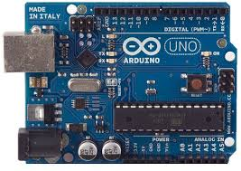

1. 16x2 LCD Display with header

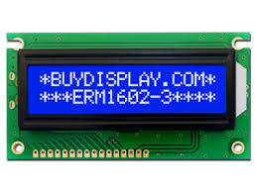

1. Soil Moisture Sensor

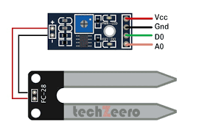

1. Water Level Sensor

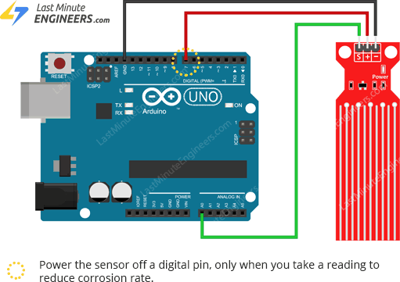

1. 5V Relay Module 2 -Channel

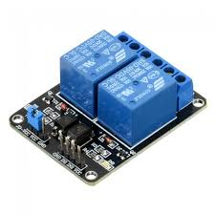

1. 12V DC Brushless Water Pump Submersible

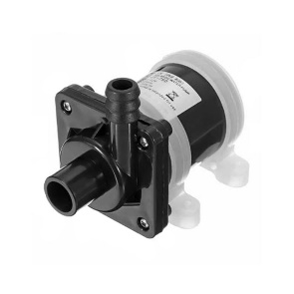

1. 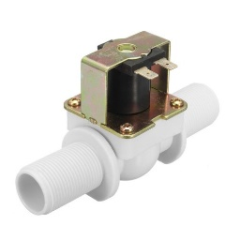12V Electric Solenoid Valve

1. Transparent Plastic Tube Hose

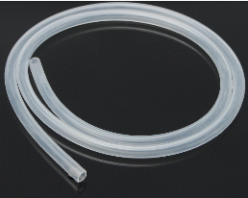

1. Piezo Buzzer

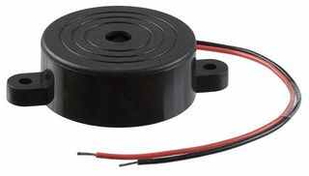

1. 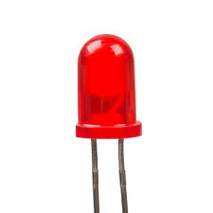LED Green(1), Yellow(1) Red(1),

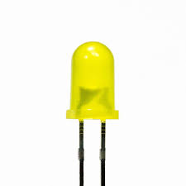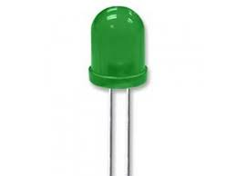

1. POT/Variable Resistor (100k)

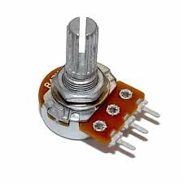

1. PVC foam board plastic flat sheet /For Modeling
2. 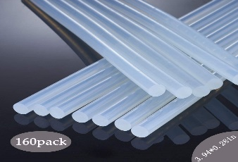Glue gun Stick
3. DC to DC Auto boost buck Convertor 1.25v-30v

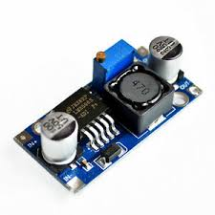

1. Stepdown Transformer /12v output

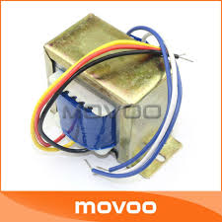

1. Bridge rectifier

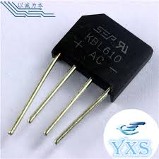

1. Electrolytic Capacitors 2200uf/25v, 1000uf/25V, 470uf/16V

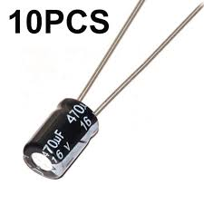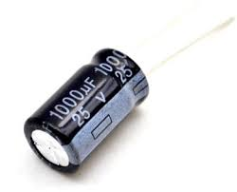**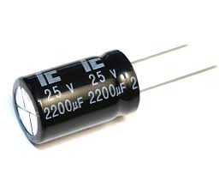2200uf/25v** **1000uf/25V,**  **470uf/16V**

1. 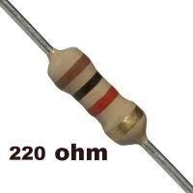Resistor 100ohm



1. Regulator LM7812 & LM7805

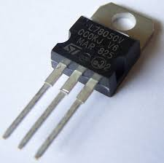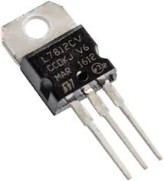**LM7812**   **LM7805**

1. 65 Jumper Wire. (22M-M,21F-F, 22F-M)

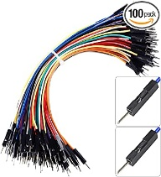

1. PCB Strip Board

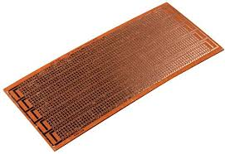

1. SPST Switch

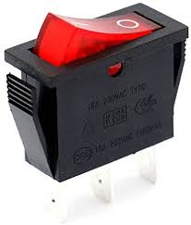

1. 2 pin terminal connector

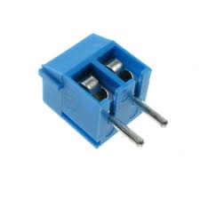

1. 2 Litter Water Bottle or Highland

1. Rectangular Plastic Food Container( For Plant Demonstration

